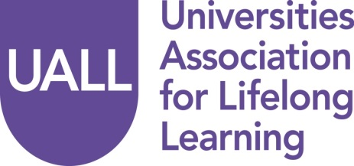
The Wider Benefits of Lifelong Learning:
The way forward in the current political climate

JOINT NETWORKS CONFERENCE

Tuesday July 7 2015, Friends House Euston
BOOKING FORM
Please complete the booking form below and return it to Lucy Bate by Friday, 19 June 2015 at: admin@uall.ac.uk. If you have any problems or questions while completing this form, please do not hesitate to contact Lucy Bate at: 01661 822185 or 07717 178 247.
Delegate Information

Name

Job title

Institution

Email

Address

Tel

Please indicate details of any dietary or special requirements

Fee: UALL members £90: non-UALL members £130

Payment to be made by cheque or BACS transfer:
Cheques should be made payable to Universities Association for Lifelong Learning and returned to: Lucy Bate, Administrator, 20 Moor Lane, Ponteland, Newcastle upon Tyne, NE20 9AD.

BACS details: Bank: Co-operative Bank, Olympic Court, Salford, M5 2QP
Sort Code: 08-92-50
Account No: 65025936
Account Name: Universities Association for Continuing Education
Alternatively, if you require your institution to be invoiced, please supply a Purchase Order Number.

Workshop Choice

1 | 2 | 3 | Please indicate your 1st, 2nd & 3rd choice of workshop
 |  |  | Flexible Pedagogy & New Technologies Michael Snowden
 |  |  | International Perspectives Nadira Mirza
 |  |  | Public Engagement Steve Kendall
 |  |  | Research Liz Marr
 |  |  | Student Experience Pauline McManus
 |  |  | Widening Participation and Access Annette Hayton
 |  |  | Work and Learning Jonathan Garnett

